SSH URLs provide access to a Git repository via SSH, a secure protocol. To use these URLs, you must generate an SSH keypair on your computer and add the **public** key to your account on GitHub.com

1. Open Terminal.
2. Paste the text below, substituting in your GitHub email address.

$ ssh-keygen -t ed25519 -C "your_email@example.com"

**Note:** If you are using a legacy system that doesn't support the Ed25519 algorithm, use:

$ ssh-keygen -t rsa -b 4096 -C "your_email@example.com"

This creates a new SSH key, using the provided email as a label.

> Generating public/private ALGORITHM key pair.

When you're prompted to "Enter a file in which to save the key", you can press **Enter** to accept the default file location. Please note that if you created SSH keys previously, ssh-keygen may ask you to rewrite another key, in which case we recommend creating a custom-named SSH key. To do so, type the default file location and replace id_ssh_keyname with your custom key name.

> Enter a file in which to save the key (/home/YOU/.ssh/ALGORITHM):[Press enter]

1. At the prompt, type a secure passphrase. For more information, see "[Working with SSH key passphrases](https://docs.github.com/en/authentication/connecting-to-github-with-ssh/working-with-ssh-key-passphrases)."
2. > Enter passphrase (empty for no passphrase): [Type a passphrase]

> Enter same passphrase again: [Type passphrase again]

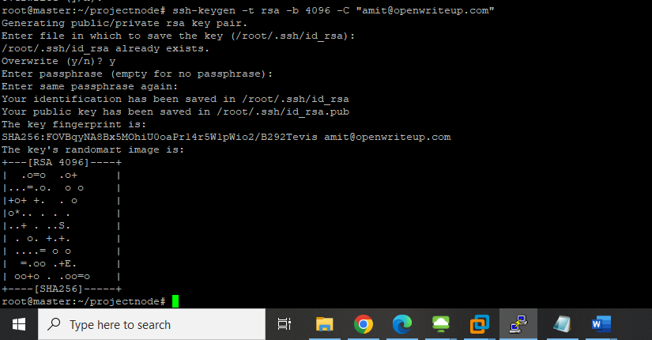

Add ssh key to github account

1. Copy the SSH public key to your clipboard.

If your SSH public key file has a different name than the example code, modify the filename to match your current setup. When copying your key, don't add any newlines or whitespace.

$ cat ~/.ssh/id_ed25519.pub

# Then select and copy the contents of the id_ed25519.pub file

# displayed in the terminal to your clipboard

**Tip:** Alternatively, you can locate the hidden .ssh folder, open the file in your favorite text editor, and copy it to your clipboard.

1. In the upper-right corner of any page, click your profile photo, then click **Settings**.

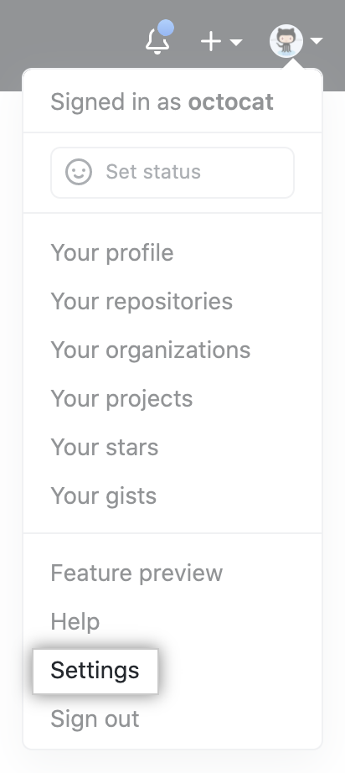

1. In the "Access" section of the sidebar, click **SSH and GPG keys**.
2. Click **New SSH key** or **Add SSH key**.

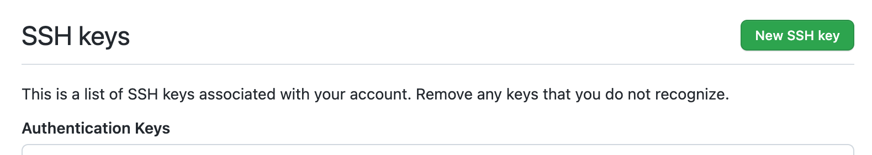

1. In the "Title" field, add a descriptive label for the new key. For example, if you're using a personal laptop, you might call this key "Personal laptop".
2. Select the type of key, either authentication or signing. For more information about commit signing, see "[About commit signature verification](https://docs.github.com/en/authentication/managing-commit-signature-verification/about-commit-signature-verification)."
3. Paste your public key into the "Key" field.

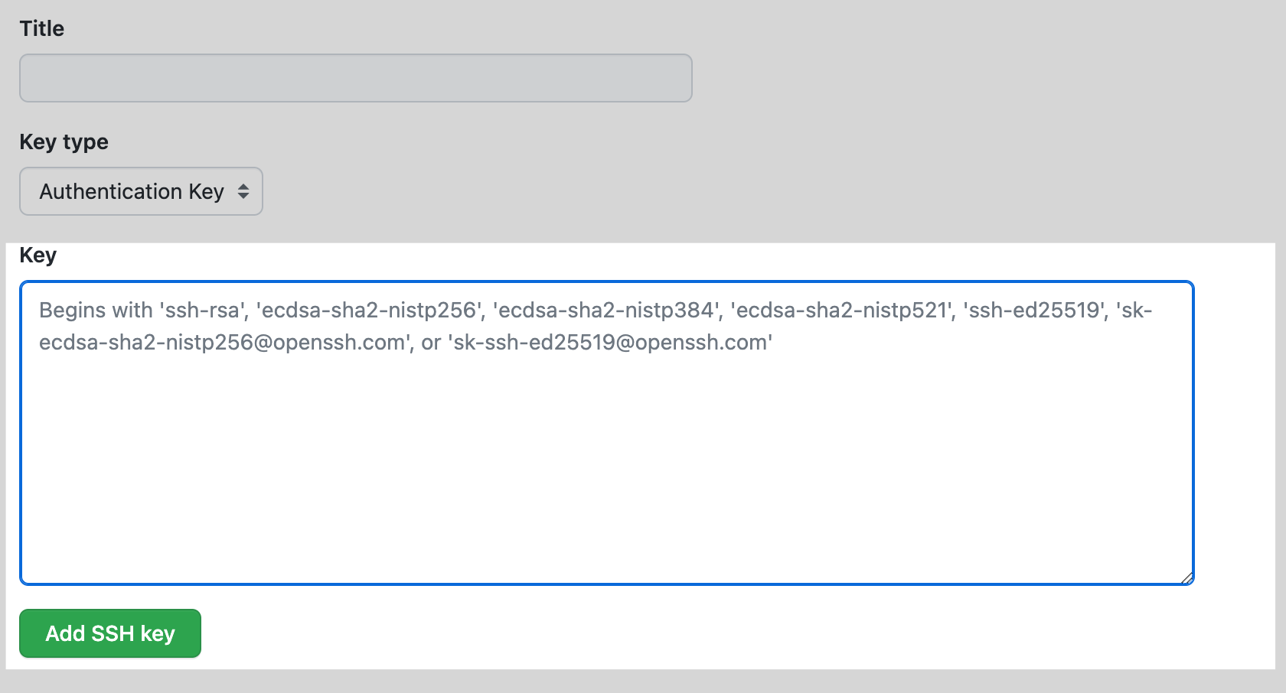

1. Click **Add SSH key**.
2. If prompted, confirm access to your account on GitHub. For more information, see "[Sudo mode](https://docs.github.com/en/authentication/keeping-your-account-and-data-secure/sudo-mode)."